Post API Test – Using Postman

# Test Case Documentation

|  |  |  |  |  |  |
| --- | --- | --- | --- | --- | --- |
| **Test Case ID** | **Test Case Description** | **API Endpoint** | **Request Type** | **Expected Response** | **Actual Response** |
| TC1 | Wrong Field Name  (user_email changed to email) | api/ addTransaction | POST | User not authenticated | User not authenticated |
| TC2 | Valid Input | api/ addTransaction | POST | Transaction created successfully | Transaction created successfully |
| TC3 | Empty Input | api/ delete-transaction | POST | Transaction ID is required | Transaction ID is required |
| TC4 | Wrong Transaction ID | api/ delete-transaction | POST | Transaction not found | Transaction not found |
| TC5 | Valid Input | api/ delete-transaction | POST | Transaction deleted successfully | Transaction  Deleted successfully |
| TC6 | Already deleted Transaction | api/ delete-transaction | POST | Transaction not found | Transaction not found |

**Test Case 1: Wrong Field Name (user_email changed to email)**

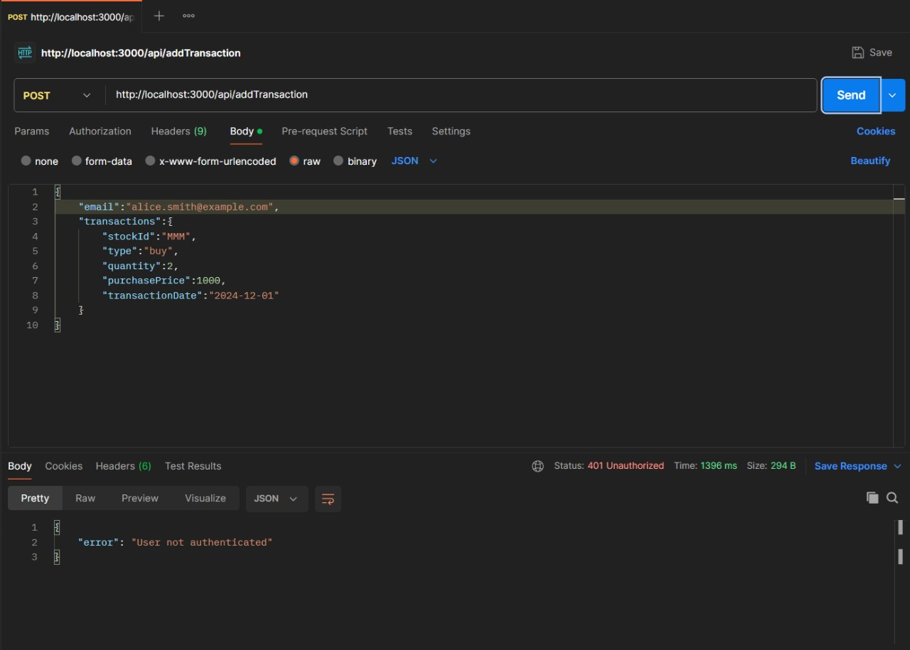

**Test Case 2: Valid Input**

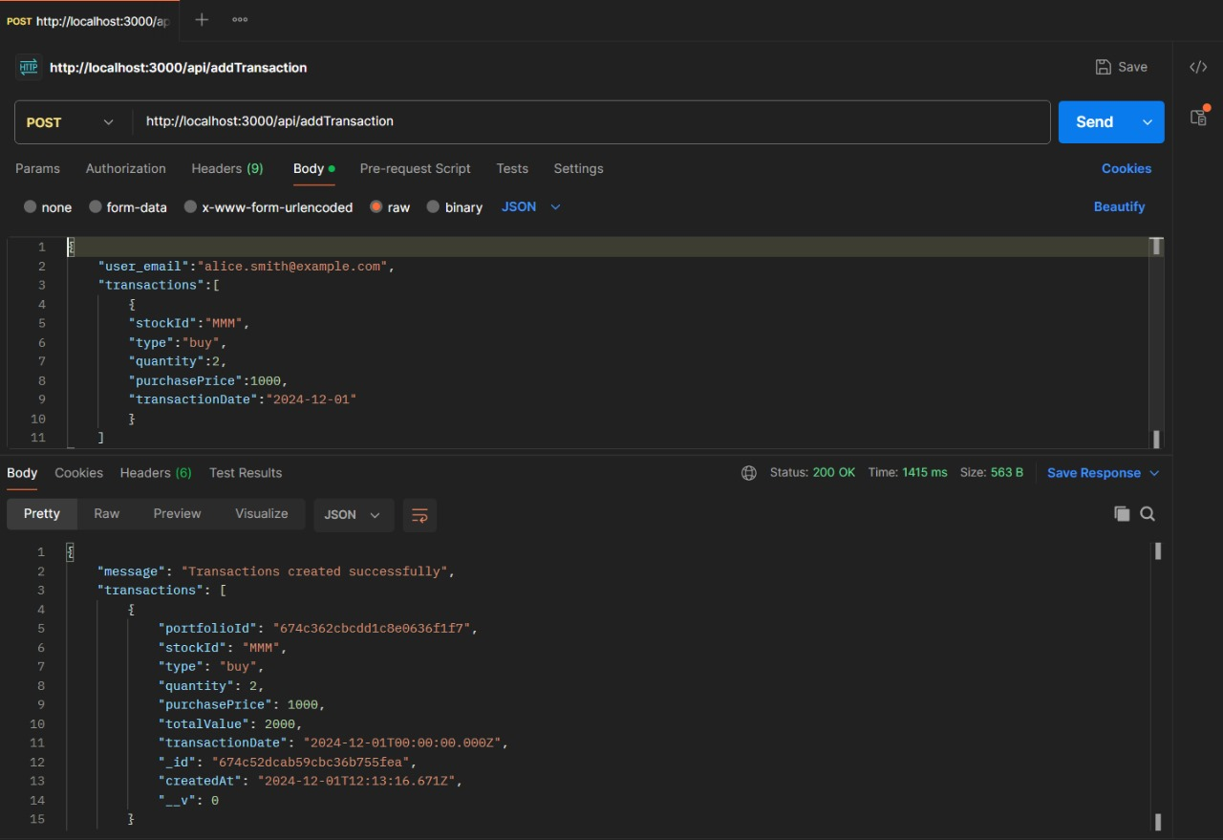

**Test Case 3: Empty Input**

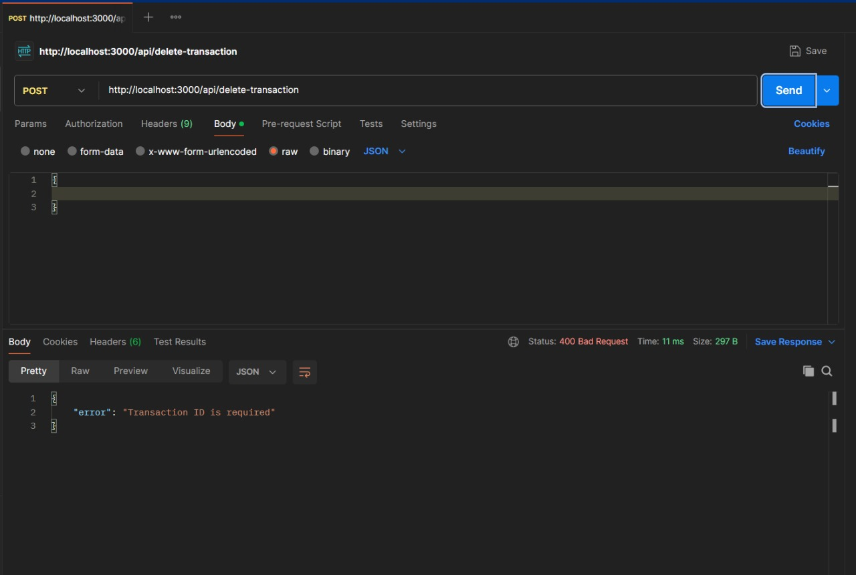

**Test Case 4: Wrong Transaction ID**

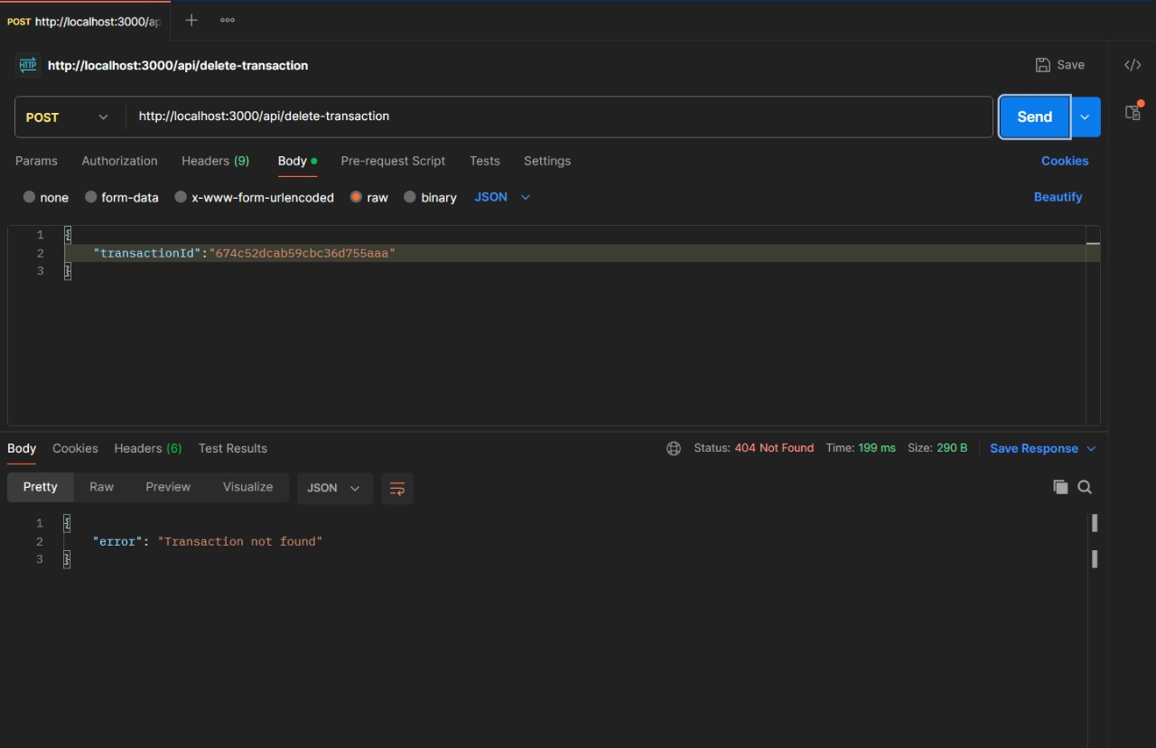

**Test Case 5: Valid Input**

